**Parking Management System**

**Project Synopsis**

Mini Project(MCA363)

Degree

**MASTER OF COMPUTER APPLICATION**

|  |  |
| --- | --- |
| PROJECT GUIDE:  **Mr. Vineet Saxena** | SUBMITTED BY:  **Prashant Shivach (TCA2163072)**  **Prince Kumar Yadav (TCA2163073)**  **Ritik Yadav (TCA2163076)** |

**COLLEGE OF COMPUTING SCIENCES AND INFORMATION TECHNOLOGY**

**TEERTHANKER MAHAVEER UNIVERSITY, MORADABAD**

Table of Contents

1 Project Title 3

2 Domain 3

3 Problem Statement 3

4 Project Description 3

4.1 Scope of the Work 3

4.2 Project Modules 3

5 Implementation Methodology 3

6 Technologies to be used 4

6.1 Software Platform 4

6.2 Hardware Platform 4

6.3 Tools 4

7 Advantages of this Project 4

8 Future Scope and further enhancement of the Project 4

9 Team Details 4

10 Conclusion 5

11 References 5

# Project Title

Parking Management System

# Domain

Database Management System

# Problem Statement

The project entitled Automated Car Parking system is to manage

the car parking bay. This software help the company to track all the

cars, car location, car in and car out details, apart from this it also help

in accounting. Using this software we can track total amount collected

for each day

The project entitled Automated Car Parking system is to manage

the car parking bay. This software help the company to track all the

cars, car location, car in and car out details, apart from this it also help

in accounting. Using this software we can track total amount collected

for each day

The project entitled Automated Car Parking system is to manage

the car parking bay. This software help the company to track all the

cars, car location, car in and car out details, apart from this it also help

in accounting. Using this software we can track total amount collected

for each day

The project entitled Automated Car Parking system is to manage

the car parking bay. This software help the company to track all the

cars, car location, car in and car out details, apart from this it also help

in accounting. Using this software we can track total amount collected

for each day

The project entitled Automated Car Parking system is to manage

the car parking bay. This software help the company to track all the

cars, car location, car in and car out details, apart from this it also help

in accounting. Using this software we can track total amount collected

for each day

The project entitled Automated Car Parking system is to manage

the car parking bay. This software help the company to track all the

cars, car location, car in and car out details, apart from this it also help

in accounting. Using this software we can track total amount collected

for each day

The project entitled Automated Car Parking system is to manage

the car parking bay. This software help the company to track all the

cars, car location, car in and car out details, apart from this it also help

in accounting. Using this software we can track total amount collected

for each day

The project entitled Automated Car Parking system is to manage

the car parking bay. This software help the company to track all the

cars, car location, car in and car out details, apart from this it also help

in accounting. Using this software we can track total amount collected

for each day

The project entitled Automated Car Parking system is to manage

the car parking bay. This software help the company to track all the

cars, car location, car in and car out details, apart from this it also help

in accounting. Using this software we can track total amount collected

for each day

The project entitled Automated Car Parking system is to manage

the car parking bay. This software help the company to track all the

cars, car location, car in and car out details, apart from this it also help

in accounting. Using this software we can track total amount collected

for each day

The project entitled Automated Car Parking system is to manage

the car parking bay. This software help the company to track all the

cars, car location, car in and car out details, apart from this it also help

in accounting. Using this software we can track total amount collected

for each day

The project entitled Automated Car Parking system is to manage the car parking bay. This software help the company to track all the cars, car location, car in and car out details, apart from this it also help in accounting. Using this software we can track total amount collected for each day

The project entitled Automated Car Parking system is to manage

the car parking bay. This software help the company to track all the

cars, car location, car in and car out details, apart from this it also help

in accounting. Using this software we can track total amount collected

for each day

# Project Description

Automated Car Parking system is a software application software to track car bay vacant positions in the multistoried buildings. Software have the provision to collect all the details of each car came to parking, in time, out time, amount etc.

## Scope of the Work

Automatic multistoried car parking system helps to minimize the car parking area. In the modern world, where parking-space has become a very big problem, it has become very important to avoid the wastage of space in modern big companies and apartments etc. In places where more than 100 cars need to be parked, this system proves to be useful in reducing wastage of space. This Automatic Car Parking System enables the parking of vehicles, floor after floor and thus reducing the space used.

## Project Modules

***Module 1: Vehicle***

* *It contains all the functionalities related to vehicle*

***Module 2: Bill module***

* *Manages the bill related functionalities*

# Implementation Methodology

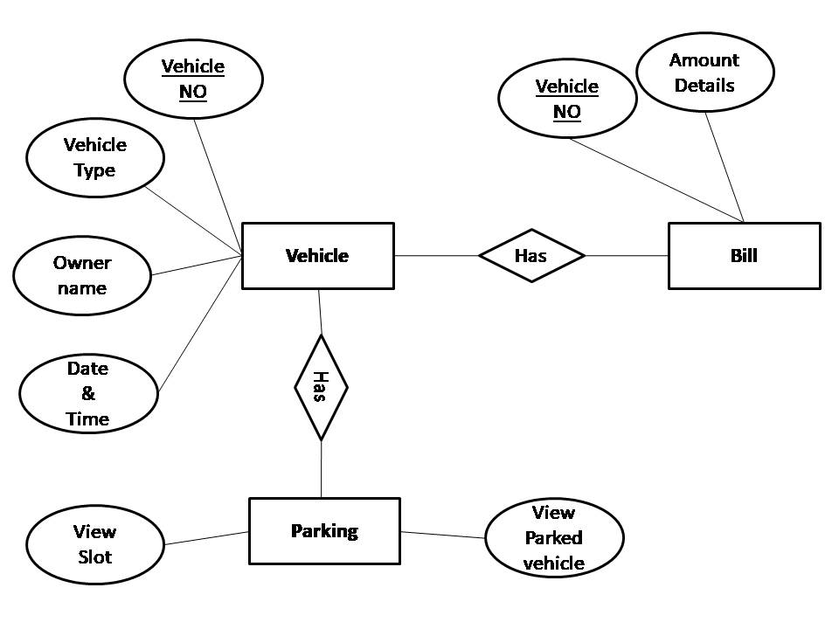**USE CASE diagram** 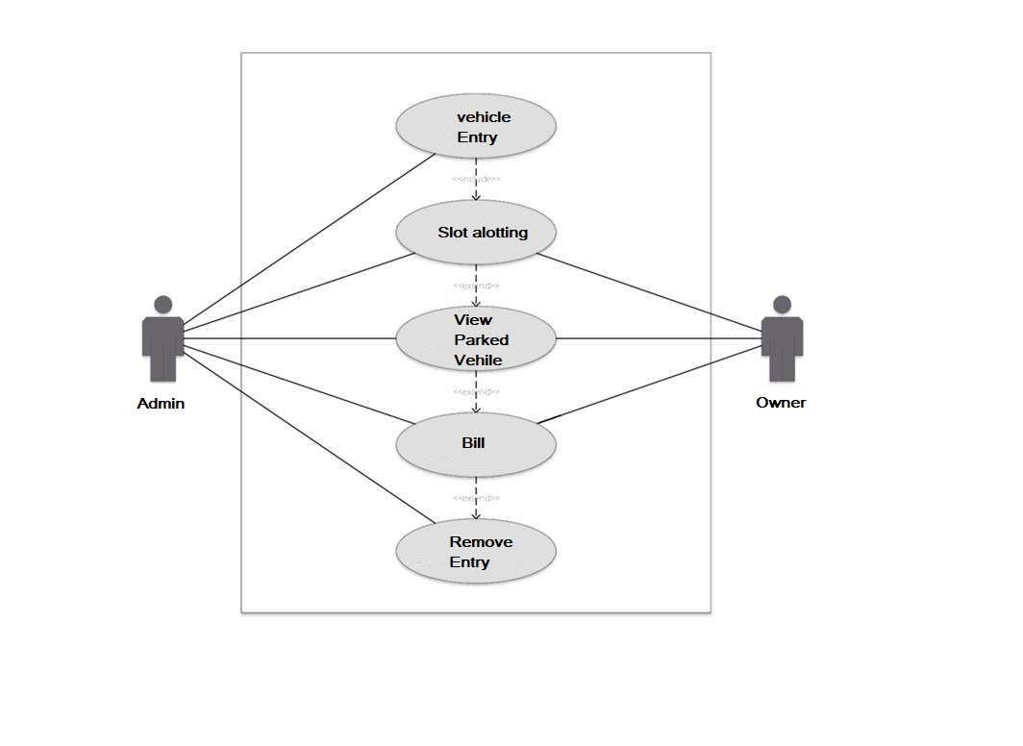

**Entity Relationship Diagram (ERD)**

# Technologies to be used

## Software Platform

1. **Front-end**

PyCharm IDE Platform

1. **Back-end**

MySQL , Python

## Hardware Platform

* Intel Core Duo 2.0 GHz or more (Processor)
* RAM – 8GB
* Hard Disk – 1TB
* OS – Windows 10
* Editor – Pycharm
* Browser – Google chrome
* **Tools** :- XMAP

# Advantages of this Project

1. **Enhanced Parking**

This enables drivers to quickly find the best spot available which will save time, resource and effort.

**2. Reduced Congestion**

Traffic flow around the parking lot will increase as overcrowding of vehicles will decrease.

**3. Reduced Pollution**

It goes along with reduced congestion. Smart parking opens the option of quicker parking which decreases the emissions by car standing idle in parking lot looking for space.

**4. Enhanced User Experience**

Parking management solution will expand and enhance the experience for a user by giving them a unified procedure.

**5. Driver's Experience**

Parking management solution helps driver find a space quickly and easily with zero frustration level. It enables them to have a seamless experience.

**6. Improved Safety**

Safety and security can be achieved easily by smart parking. Data can be provided to parking lot employees for better management and lookout for violations and suspicious activities.

# Future Scope and further enhancement of the Project

**The Smart parking system based on Slot booking is implemented**. Using the slot allocation method we can book our own cheapest parking slot. It is an efficient one for solving parking problems, which overcomes the traffic congestion also provides automated billing process.

# Team Details

| **Project Name & ID** | **Course Name** | **Student ID** | **Student Name** | **Role** | **Signature** |
| --- | --- | --- | --- | --- | --- |
| Parking management system | MASTER OF COMPUTER APPLICATION | TCA2163072 | Prashant Shivach | Tester |  |
| TCA2163073 | Prince kumar yadav | Developer |  |
| TCA2163074 | Ritik Yadav | designer |  |
|  |  |  |  |
|  |  |  |  |

# Conclusion

This project provide all the necessary information and also provide the services which are used by the agents to complete their daily tasks and it also store the customer’s information which provide convince to the agents and help them to deal with their customers with the simple and user friendly interface that help the users of this application.

# References

* + Google for problem solving
  + <http://www.tutorialspoint.com/mysql/>
  + Database Programming with pycharm